Assignment-1

Bar Chart – Total Sales by City
This chart shows the total sales generated in each city. It helps identify which city has the highest customer spending.
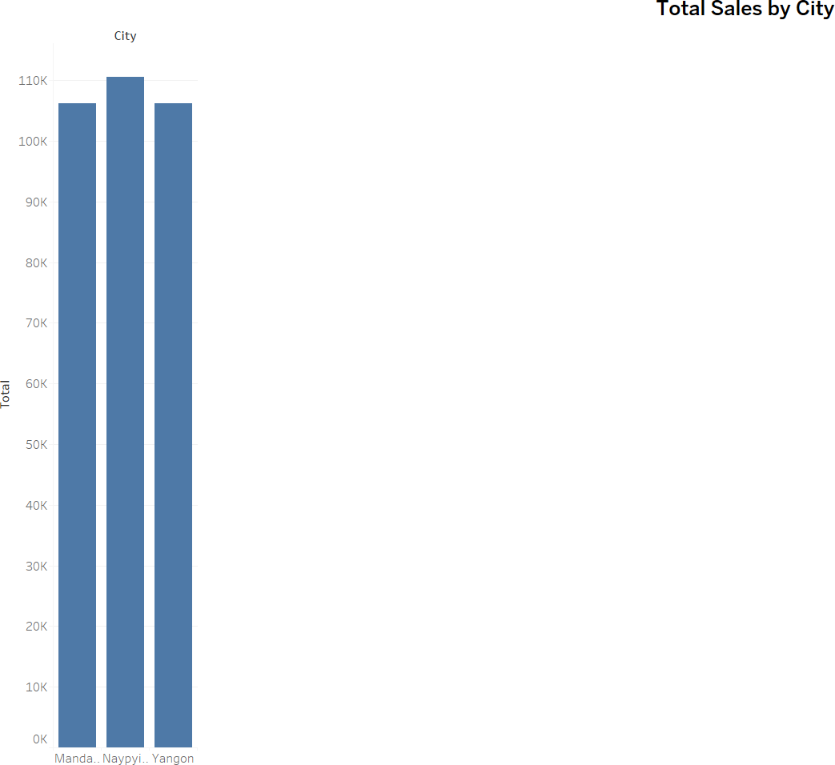

Pie Chart – Sales Distribution by Payment Method

This pie chart displays the share of total sales by different payment methods: Cash, Credit Card, and Ewallet. It reveals customer preferences in transaction modes.
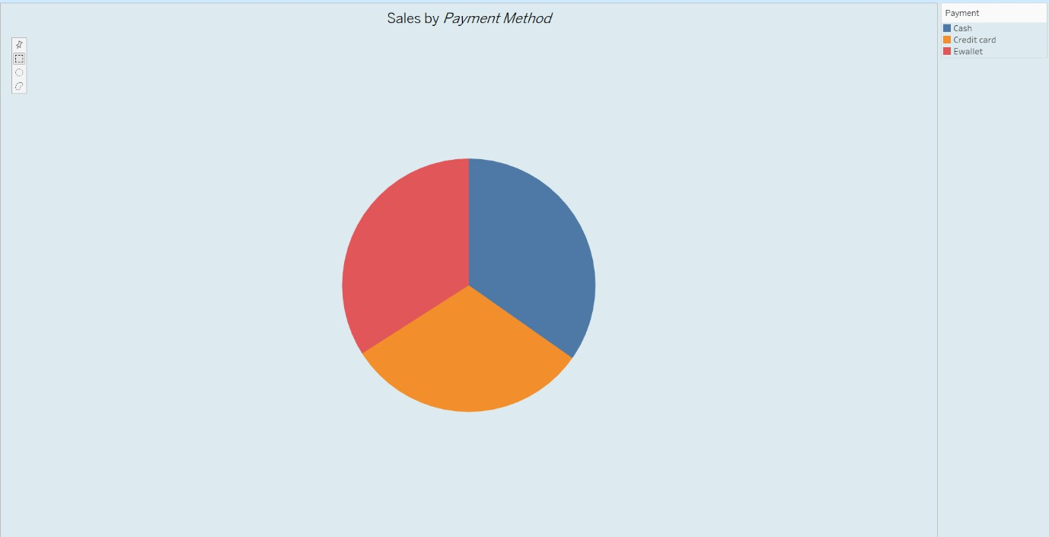

Stacked Bar Chart – Branch-wise Sales by Customer Type
This chart compares total sales across branches (A, B, C), and further breaks them down by customer type (Member vs Normal). It helps understand branch performance and
membership influence.

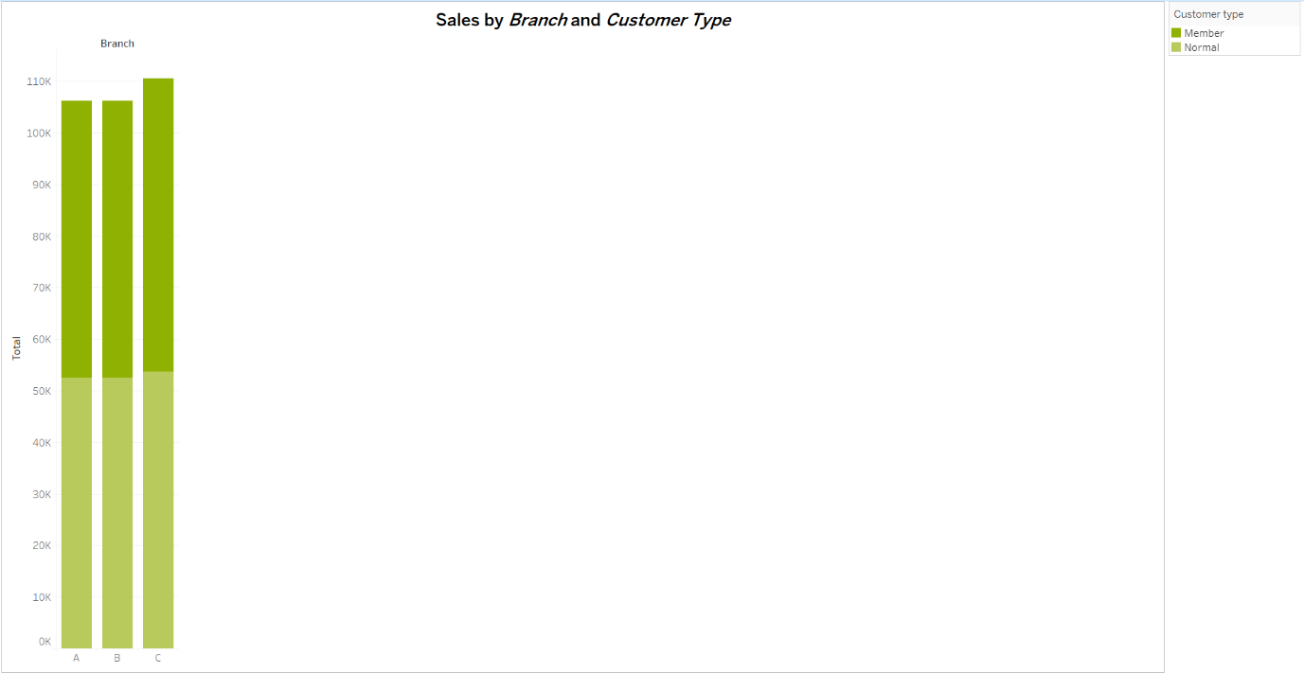

Line Chart – Monthly Sales Trend Over Time
The line chart presents how sales varied over time from January to March. It helps spot trends and peak sales days.

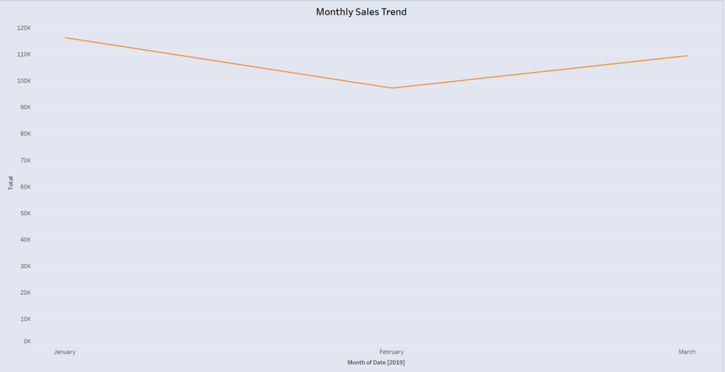

Bubble Chart – Gross Income by Quantity and Product Line
This chart uses bubbles to represent gross income earned from different product lines, based on the quantity sold. Larger bubbles indicate higher profit areas.
